Botswana Luxury Safari & Cape Town

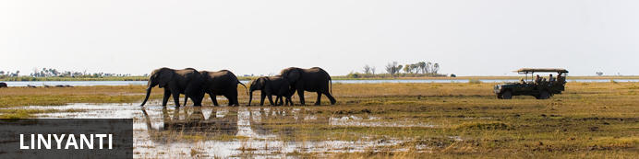
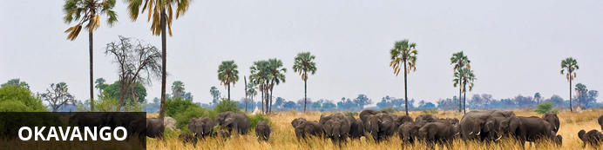
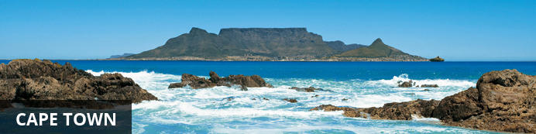

Botswana Luxury Safari & Cape Town
Linyanti - Okavango - Cape Town
10 Days / 9 Nights
2 Persons

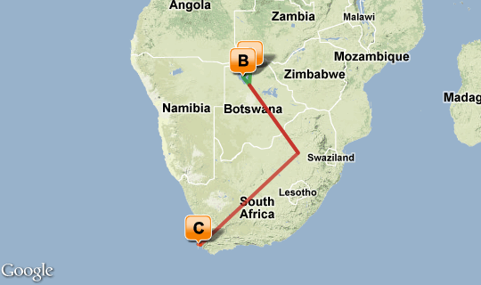

Click here to view your Virtual Itinerary

Overview
Luxury Botswana safari at 2 of the iconic properties, Zarafa in the Selinda / Linyanti and thereafter at Little Mombo, in the famed Mombo concession on Chiefs Island, Okvango Delta. Ending in Cape Town at the impressive Ellerman House with its magnificent sea views and impeccable service.

Destination | Accommodation | Nights | Basis | Room Type
Linyanti | Zarafa Camp | 2 | FI
Okavango | Little Mombo Camp | 3 | FI
Cape Town | Ellerman House | 4 | B&B

Key
B&B: Bed and breakfast
D, B&B: Dinner, bed and breakfast
FB: Dinner, bed, breakfast and lunch
FB+: Dinner, bed, breakfast, lunch and activities daily
FI: Fully inclusive

Day 1: Zarafa Camp | Selinda Reserve (Linyanti)

Day Description
Arrival in to Johannesburg OR Tambo International airport we will have the clients met airside for VIP arrival and assistance off the plane ramp ( please advise flight details). Assistance provided to onward connection to Maun, Botswana – Note: Clients can remain in transit if they check luggage through, but usually we recommend to collect and re-check luggage and clear customs in to South Africa
Departure with onward schedule flight ( not included and for clients account) to Maun (MUB), Botswana
On arrival in to Maun, met by our representative and assistance provided to awaiting air charter for light aircraft transfer
Important note: Please note that luggage restricted to max 20kgs per person in soft style bags, with no card sides, bottoms and no wheels.. Luggage needs to be able to fit in to the luggage areas on light aircrafts.
Continue with air transfer onward to your camp located in the private Selinda Reserve

Zarafa Game Drives
4x4 landcruiser safaris and cruises on their lagoon

2 Overnights: Zarafa Camp in luxury tented suites View iBrochure
Zarafa Camp, located in the 320,000-acre Selinda Reserve is synonymous with exclusivity and perfection. The spirit behind Zarafa Camp comes from Colin Bell, Dereck and Beverly Joubert, who together designed Zarafa to incorporate all the components of what they envisioned as the ‘perfect’ safari camp. It embodies authenticity, luxury and simplicity to create a camp that as been clearly considered, and thoughtfully planned to be as environmentally sensitive as possible. It is the culmination of years of safari experience.
Re-opened in June 2008 as Zibadianja Camp and later re-named Zarafa, its beautiful design, ‘green’ construction and spectacular new location made it an immediate recipient of numerous accolades. Zarafa Camp sits on an island in the floodplains of southern shores of the Zibadianja Lagoon, which is the source of the Savute Channel. Positioned in the extreme eastern side of the Selinda Reserve, its location is in prime wildlife territory.
Each of the camp’s four immense tented suites are raised up on wooden decking and shaded by a canopy of African ebony and Red ivory trees, each with uninterrupted views.
Zarafa means "the beloved one" or "the lovely one" in Arabic. The name comes from a giraffe, which was presented to Charles X of France in 1826 by the Viceroy of Egypt. The giraffe was a sensation to all who saw her, and provided inspiration. The new Zarafa Camp lives up to the name, inspiring even the well traveled, and renewing the spirit of all who visit.
There are few places in northern Botswana as dynamic as the Selinda Reserve, which is centred on the famous Selinda Spillway, which weaves its way east, linking the far reaches of the Okavango Delta in the south with the Linyanti water systems in the east.
The Selinda Reserve is west (upstream) from Savute Channel and Chobe, so it has all the advantages of both of those famous areas but with the tremendous advantage of exclusivity. It is a truly spectacular and unique landscape.
On safari it is possible to see a tremendous diversity of species, from resident prides of lion to huge herds of elephant and packs of wild dog. It is also home to the ungulates, from the rare roan to the ubiquitous zebra. Nocturnal wildlife is prolific as well, and there are frequent sightings of aardwolf and civet. Exploration of this vast area defies imagination... by foot, 4x4 open game drive vehicle, and pontoon boat.
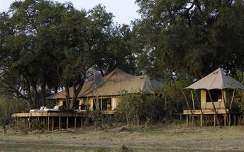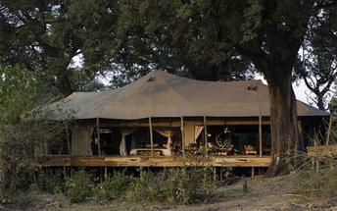

Activities
Early morning and late afternoon/early evening 4x4 open vehicle game drives, guided wildlife bush walks, and boating on Zibadianja Lagoon on HMS ZIB when water levels permit, open air gym, in-room massages.

Included
Bed, All Meals, Most Drinks(local), Fees, Activities

Day 2: Zarafa Camp | Selinda Reserve (Linyanti)

Day Description
Early morning and late afternoon/early evening 4x4 open vehicle game drives, guided wildlife bush walks, and boating on Zibadianja Lagoon on HMS ZIB when water levels permit, open air gym, in-room massages.
- Day and afternoon game drives on 4x4 open-sided Toyota Land Cruisers; each vehicle seats a maximum of 7 guests
- Night drives with spotlights
- Short walks from camp and on game drives
- Fishing with a limited supply of basic equipment is on offer seasonally - catch and release basis
- Bird watching

Activities
Early morning and late afternoon/early evening 4x4 open vehicle game drives, guided wildlife bush walks, and boating on Zibadianja Lagoon on HMS ZIB when water levels permit, open air gym, in-room massages.

Included
Bed, All Meals, Most Drinks(local), Fees, Activities

Day 3: Little Mombo | Okavango Delta ( Moremi)

Day Description
Final morning at Zarafa Camp and breakfast.
Depart from Camp to airstrip to transfer with scenic flight over the Okavango Delta to Mombo Camp renowned as one of the best wildlife safari lodges in Africa for final 3 nights safari
Note: Helicopter transfer also possible and shown as additional extra between Zarafa and Little Mombo for scenic transfer over the Delta.
On arrival at Mombo Airstrip met by 4x4 landrover and transfer to the camp for 3 nights on safari.
3 nights Little Mombo Camp luxury accommodation; including All meals, daily activities, laundry and drinks (excluding premium import brands)
Optional Helicopter scenic flights can also be arranged to transfer or have as an additional excursion for another idea to present to the client
Little Mombo Camp is an intimate extension of the larger Mombo Camp in the Moremi Game Reserve, Okavango Delta, BotswanaIt shares the same island as its sister and offers the same high standards of accommodation and big game viewing - some of the best in Botswana with panoramic vistas of the surrounding floodplains teeming with wildlife.
Little Mombo Camp is situated on Mombo Island, adjoining the northern tip of Chief's Island within the Moremi Game Reserve in the Okavango Delta, northern Botswana. It is a smaller and more intimate camp than its sister, Mombo Camp, to which it is connected via a raised walkway.
Little Mombo Camp is built under a shady canopy and has three luxurious, spacious rooms under canvas with en-suite bathrooms and outdoor showers for guests looking to get closer to nature. Much of Little Mombo Camp overlooks the surrounding floodplains which offer some of the best big game viewing in the Okavango Delta. A sala, large veranda and lounge area provide ample place to relax and enjoy the view. Little Mombo Camp also has its own dining room, kitchen and pool.
Little Mombo | Mombo Camp’s has arguably the best big game viewing in Africa. Located in the Mombo Concession on Chief's Island in the heart of the Okavango Delta, Botswana, the sheer numbers and variety of wildlife all year round defy description. Mombo Camp is the Africa only seen in documentaries: from elephant to buffalo to tiny steenbok, vast herds of herbivores are trailed by numerous predators on the hunt!
The best big game viewing experience starts on the veranda at Mombo Camp, with wonderful concentrations of game occurring right in front of the camp. Guests often find animals wandering past, right under their rooms!
Activities at Mombo Camp include morning and afternoon game drives. Open 4x4s provide an excellent vantage for viewing the high concentrations of plains game and all the predators - including the big cats. Lion sightings are frequent. Guests at Mombo Camp can also expect to see leopard, wild dog, spotted hyaena, large herds of buffalo, elephant, white rhino, southern giraffe, blue wildebeest and Burchell's zebra.
Black and white rhino have been reintroduced to the region with outstanding success (albeit most are further away from Mombo Camp), thanks to the Botswana Rhino Reintroduction Programme.

Okavango Delta
Lying in the middle of the largest expanse of sand on earth the Delta is one of Africa’s most amazing, sensitive, and complex environments supporting a spectacle of wilderness and wildlife. Unique as one of the world’s few inland deltas, the placid waters and lush indigenous forests of the Delta offer a safe haven for innumerable bird and wildlife species. The elusive Sitatunga antelope has found refuge in this pristine wetland ecosystem, while birds such as the African fish eagle, Pel's fishing owl and many others are magnificent in their spectacular display. The Okavango Delta offers a number of activities for the visitor where fishing and bird-watching are obvious attractions, but game viewing, especially for rare species, is also possible. One can also take to the waters of this magical world of islands and lagoons by canoe, mokoro or powerboat. Although a holiday here doesn't come cheap, it is an unforgettable experience.
Activities
- 100% Game drives. No water activities although guests will see water in the area at times.
- Game drives via 4 x 10-seater open 4x4 Land Rovers each accommodating a maximum of six or seven guests,
allowing each guest an outside seat (each vehicle is equipped with a tree book, a bird book, a mammal book,
a pair of binoculars and insect repellent in a centre consol on each row of seats)
- Game drives on Chief's Island
- Best game viewing in Botswana
- Night drives not possible at present
- Private vehicle on request (maximum five vehicles in the concession with three primarily being used at
Mombo main camp, one at Little Mombo and one available for private vehicle booking)

3 Overnights: Little Mombo Camp | Luxury tented suites View iBrochure
Little Mombo Camp is an intimate extension of the larger Mombo Camp in the Moremi Game Reserve, Okavango Delta, BotswanaIt shares the same island as its sister and offers the same high standards of accommodation and big game viewing - some of the best in Botswana with panoramic vistas of the surrounding floodplains teeming with wildlife.
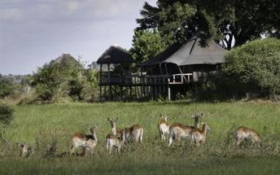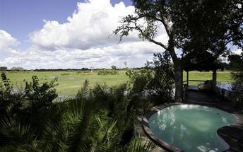

Included
Bed, All Meals, Most Drinks(local), Fees, Activities

Recommended
Helicopter Flights over the Delta ( Optional suggestion)

Day 4: Little Mombo | Okavango Delta ( Moremi))

Day Description
Safari Activities in the Mombo concession
100% Game drives. No water activities although guests will see water in the area at times.
Game drives via 4 x 10-seater open 4x4 Land Rovers each accommodating a maximum of six or seven guests, allowing each guest an outside seat (each vehicle is equipped with a tree book, a bird book, a mammal book, a pair of binoculars and insect repellent in a centre consol on each row of seats)
Game drives on Chief's Island
Best game viewing in Botswana
Note: Night drives not possible at present
Private vehicle on request (maximum five vehicles in the concession with three primarily being used at Mombo main camp, one at Little Mombo and one available for private vehicle booking)

Activities
- 100% Game drives. No water activities although guests will see water in the area at times.
- Game drives via 4 x 10-seater open 4x4 Land Rovers each accommodating a maximum of six or seven guests, allowing each guest an outside seat (each vehicle is equipped with a tree book, a bird book, a mammal book, a pair of binoculars and insect repellent in a centre consol on each row of seats)
- Game drives on Chief's Island
- Best game viewing in Botswana
- Night drives not possible at present
- Private vehicle on request (maximum five vehicles in the concession with three primarily being used at Mombo main camp, one at Little Mombo and one available for private vehicle booking)

Included
Bed, All Meals, Most Drinks(local), Fees, Activities

Day 5: Little Mombo | Okavango Delta ( Moremi)

Day Description
Safari Activities in the Mombo concession

Activities
- 100% Game drives. No water activities although guests will see water in the area at times.
- Game drives via 4 x 10-seater open 4x4 Land Rovers each accommodating a maximum of six or seven guests,
allowing each guest an outside seat (each vehicle is equipped with a tree book, a bird book, a mammal book,
a pair of binoculars and insect repellent in a centre consol on each row of seats)
- Game drives on Chief's Island
- Best game viewing in Botswana
- Night drives not possible at present
- Private vehicle on request (maximum five vehicles in the concession with three primarily being used at
Mombo main camp, one at Little Mombo and one available for private vehicle booking)

Included
Bed, All Meals, Most Drinks(local), Fees, Activities

Recommended
Helicopter Flights over the Delta ( Optional suggestion)

Day 6: Cape Town (Mon, 23 April)

Day Description
Transfer with light aircraft for schedule charter transfer to Maun Airport +_25mins flight.
Connect with onward schedule flight service ( not included) and to be included with your international tickets with Air Botswana (BP), from Maun. Botswana to Johannesburg, Connect with onward flight Johannesburg to Cape Town ( your account)
On arrival in to Cape Town Airport, clear customs and immigration back in to South Africa. Met by private locally based Guide based on English speaking guide for Cape Town section for touring or transfer provided by one of Ellerman Houses luxury vehicles to the property
Transfer to Ellerman House
Note: If language guide required we can arrange for a supplement – Please advise

4 Overnights: Ellerman House based on Suite 11 “ East Wing Suite” View iBrochure

Ellerman House overlooks the Atlantic Ocean and Robben Island from a commanding position above Cape Town’s Bantry Bay. Just 10min drive to the V&A Waterfront, and a 5min walk to the beaches of Clifton and Camps Bay. Created for the enjoyment of the finer things in life, this gracious Cape Edwardian mansion with shaded verandahs and tiered gardens, has beautifully appointed interiors and one of the finest private art collections in South Africa.
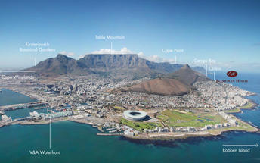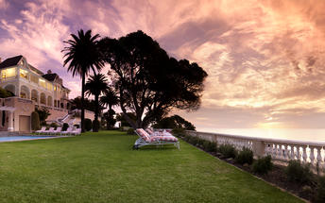

Included
- Made-to-order breakfasts including fresh-pressed juices and home-baked breads and pastries
- Hand-finished laundry packed in tissue paper
- Complimentary teas, coffees ,spirits and beer
- Fully stocked in-room bar with luxury brands
- Guest pantry with wide selection of snacks and in-between meal options
- Sunset cocktails
- Broadband wireless Internet access
- 24-hour monitored security
- Private and secure parking
- Individual attention from Senior Managers who personally supervise Guest services.

Rates Exclude:
- Lunch and dinner
- Invited guests' meals and drinks
- Wines and Champagne
- Telephone calls and fax transmissions.

Cape Town
Cape Town is one of the world's most beautiful cities and a top international destination. Large volumes of tourist flock to Cape Town to enjoy this unique city with it's facsinating history, interesting culture, natural beauty, award winning wines and laidback lifestyle. Whether you are a serious tourist or just want to lie on the beach and enjoy life Cape Town will satisfy your needs.

Day 7: Ellerman House | Cape Town

Day Description
Depart Ellerman House at approximately 9:00am with private vehicle and guide for Cape Town City Tour Half Day
On a clear day from the summit of Table Mountain you get spectacular views of the City, its Waterfront, Camps Bay, the majestic Hottentots Holland Mountains to the East and the mountains of the Cape Peninsula all the way down to Cape Point to the south.
The Table Mountain cableway, a must for all visitors to the Cape, boasts revolving floors, giving passengers a 360 degree view. After descending the mountain, you will depart on a tour of the “Mother City” taking in Signal Hill – where the Noon Day Gun is fired at midday, every day except Sunday – through the colourful Bo-Kaap or Cape Malay Quarter, past the Grand Parade, City Hall and the Castle of Good Hope and South African Cultural History Museum.
You are then taken on a city tour, which includes a visit to the Castle, a drive through the city centre, a stop in the picturesque Malay (Muslim) Quarter, the architecture in this area is typical of what Cape Town was like 200 years ago. Then visit to the Waterfront or Milnerton for views of Cape Town. You will go past the houses of parliament, visit two or three of our famous museums and visit the company gardens.

Highlights:
• A tour of the Malay Quarter
• Cape Town city centre
• Company Gardens
• Greenmarket Square
• The flower sellers and the Castle of Good Hope.
Have included entrance fees to The Castle of Good Hope and two museums. No Lunch included, but you can stop for a nice local lunch locally or return to Ellerman
Remainder of the day at leisure
-Evening at leisure and we can recommend some great restaurants, though for seafood suggest Baia Restaurant – Very nice!

Ellerman Houses Included
Made-to-order breakfasts including fresh-pressed juices and home-baked breads and pastries
Hand-finished laundry packed in tissue paper
Complimentary teas, coffees ,spirits and beer
Fully stocked in-room bar with luxury brands
Guest pantry with wide selection of snacks and in-between meal options
Sunset cocktails
Broadband wireless Internet access
24-hour monitored security
Private and secure parking
Individual attention from Senior Managers who personally supervise Guest services.

Day 8: Ellerman House | Cape Town

Day Description
Depart Ellerman House at approximately 9:00am with private vehicle and guide for full day Cape Peninsular tour
Depart along the spectacular Atlantic Seaboard. We drive through the coastal suburbs of Sea Point, Bantry Bay and Clifton. We will stop for a photo opportunity of Table Mountain's impressive Twelve Apostles. We then travel on past Bakoven and Llandudno which are marked by shipwrecks which fell foul to the infamous Cape winter storms, then on to the scenic fishing village of Hout Bay.
Alex an optional extra would be to board a boat to view the Cape Fur Seal colony on Duiker Island is wanted
We will also head over the 600m heights of Chapman's Peak Drive, which is without a doubt one of the world's most spectacular mountain passes. You will also have a chance to watch Southern Right Whales frolicking just offshore from June to November.
Explore the rocky coastline and unique Cape Fynbos vegetation which is home to unique birdlife such as African Black Oystercatchers and Cape Sugarbirds amongst others. The opportunity is also there to view small animals such as the Cape Mountain Zebra, Bontebok, ostrich and Baboon as we enter the Cape of Good Hope National Park. Climb to the famous Cape Point Lighthouse to capture the magical vistas of False Bay, and stop at the south western most point of Africa - the fabled Cape of Good Hope. (A funicular is an optional extra for those who prefer)
Lunch (for your own account) will be at one of the restaurants of your choice after having been giving suggestions by your guide. We will visit Boulders Beach for an exciting close up encounter with African Penguins. Drive through the historical naval village of Simonstown and over yet another spectacular mountain pass; Boyes Drive, where you will take in views of the quaint fishing harbour at Kalk Bay as well as the seaside villages of St James and Muizenberg.
Visit Kirstenbosch Botanical Gardens - with time to browse these magnificent gardens set on the slopes of Table Mountain before returning to the city.
Please note that tours are subject to a change in direction due to weather and traffic conditions
Highlights:
• Cape Point and the Cape of Good Hope
• Boulders Beach – Penguin Colony
• Hout Bay – optional boat trip to Seal Colony
• Simonstown historical naval base
• Fynbos vegetation
• The chance of seeing baboons, bontebok, ostriches, bird life and the Southern Right Whales (seasonal)
• Kirstenbosch Botanical Gardens
Includes a private driver/guide, entrance fees to Cape Point, Boulders Beach Penguin Sanctuary and Kirstenbosch Botanical Gardens. Lunch at your own cost will be at the suggestion of the guide once he finds out your preference or he can make suggestions.
You should return Ellerman House at about 17:00/ 17:30pm.

Day 9: Ellerman House | Cape Town

Day Description
Depart Ellerman at approximately 9:00am with private vehicle and guide for full day Cape Winelands tour.
Depart to Winelands region of Stellenbosch, Paarl and Franschhoek for a leisurely exploration of these historic Wine Route towns.
Wine estates visited will vary according to client preferences, but the tour includes the region's major wine producing areas. The tastings include high quality (and often award winning) red and whites wines.
Lunch (for your own account) will be at one of the spectacular restaurants in the area where the chefs regularly receive awards for their outstanding cuisine.
There are many natural and historic heritage places in this area and your guide will take you past many sights like the Afrikaans Taal Monument amongst others. The majestic scenery in the area is unparalleled so even if you don’t drink wine, the countryside and the history make it well worth the visit.
Stellenbosch, with its tree lined streets, historical architecture, alfresco cafes and good shopping is South Africa’s second oldest town, while Franschoek is a food lovers delight and Paarl has the historical Taal monument to boast along with spectacular scenery.
Highlights:
• Stellenbosch, tree lined streets, historical architecture, alfresco cafés and good shopping
• Franschhoek Valley with its endless mountain vistas
• Paarl – “the pearl of the Cape” – home to the Afrikaans language
• Cape Dutch architecture – visit the acclaimed Boschendal Manor House (subject to change)
• Wine tasting on some of the finest Cape Wine Estates
• Cellar tour
Add-on options for private tours: For your information for suggestions to enhance for clients
Horse riding in the vineyards, hot air ballooning, helicopter transfer to the Winelands, long leisurely lunch at one of the Cape’s top restaurants, pamper yourself with a spa visit.
Includes entrance fees for 3 tastings and a cellar tour.

Day 10: Departure Cape Town

Day Description
Breakfast and time at leisure before private transfer to Cape Town Airport.
Departure or continue with onward arrangements homeward
END OF SERVICES

Transport

Flight Information
Date | Flight | Departure Airport | Time | Arrival Airport | Time | Notes
Day 1 | BP212 | OR Tambo International Airport [JNB] | 10:00 | Maun Airport [MUB] | 12:20 | Not included
 |  | Maun Airport [MUB] | TBA | Selinda Airstrip | TBA
Day 3 |  | Zarafa Camp | TBA | Mombo Airstrip | TBA
Day 5 | Charter | Little Mombo Camp | 12:00 | Maun Airport [MUB] | 12:35
 | BP 211 | Maun Airport [MUB] | TBA | OR Tambo International Airport [JNB] | TBA | Not included
 | SAA/BA | OR Tambo International Airport [JNB] | TBA | Cape Town International Airport [CPT] | TBA | Not Included

Transfers
Date | Pick Up | Drop Off | Time | Vehicle
Day 5 | Cape Town International Airport [CPT] | Ellerman House | 0:00 | Luxury Audi Q7, or similar
Day 9 | Ellerman House | Cape Town International Airport [CPT] | 0:00 | Luxury Audi Q7, or similar

